 | Maths | Phonics | Talk/Rhyme Time | Theme | Story
Monday | (These activities will be taught on Seesaw every day)  Can you count from 1 to 10 in different voices?  In a whisper, a loud voice, or in a pirate voice?  Musical Statues/numbers!  (An adult –or child, will need to write numbers 1 to 5 on separate bits of paper and place them around the floor.)  Dance to some music when the music stops an adult will shout a number 1,2,3,4 or 5. You have to quickly stand on that number and freeze!  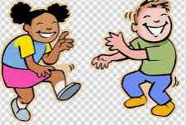 | Today we are reading the story The Grufffalo. You can watch Mrs Stephenson reading it on Seesaw or watch it on https://www.youtube.com/watch?v=FJldiCp-33c  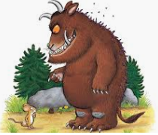 | Can you describe the Gruffalo? Read these facts, can your child say if they are true- yes! Or false No!  - The Gruffalo is small. Yes or no?  - The mouse is brave? Yes or no?  - The story takes place in a farm? Yes or no?  - The owl has feathers? | Can you move like the characters in the book?  An Owl swooping  The mouse scurrying,  The Gruffalo stamping  The snake slithering  The fox running  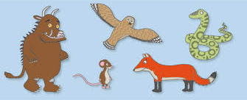 | Watch Owl Babies- This is another story set in the woods! With an Owl in!  https://www.youtube.com/watch?v=TPQRiSTYFHo
Tuesday | Maths  (This activity is on Seesaw)  Sing 1,2,3,4,5 Once I caught a fish alive,  6,7,8,9,10, then I let it go again.  Why did you let it go? Because it bit my finger so. Which finger did he bite?  This little finger on my right!  https://www.youtube.com/watch?v=9ir_l7qTiZ4  Can you count the Gruffalo’s stamping feet?  Can you stamp 3 times and write number 3?  Four times?  There is also a woodland counting worksheet available. | Watch Seesaw and listen to Mrs Kennedy reading a new story- with the Gruffalo in!  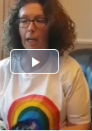 | Phone a friend or family and tell them what the Gruffalo story is about! | Can you draw a picture of the Gruffalo? You can use the worksheet on Seesaw- draw straight onto it!  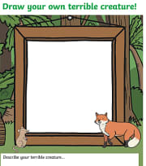 | Listen to story Read your favourite story to your mum or dad!
Wed | Maths  Look around the house,  Can you find big and small objects around the house and sort them?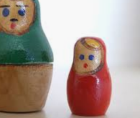  Can you make your bodies big, huge, large, massive, and gigantic like the Gruffalo?  Or small, tiny and little like the mouse? | Phonics-  Ask your child:  What do we listen and hear with?  What do we smell with?  What do we feel/touch with?  What do we taste with?  What do we see with?  Have a box of things ready!- eg, a crisp packet, some keys, a bottle of water, a roll of cellotape.  Get your child to close their eyes,  Make a noise using one of the things,  Can they guess what it is? | Can you go on a walk around the house or outside and think about all the smells you can smell! | Play the game BEANS!  Runner bean is running around  Jumping bean is jumping up and down  String bean is stretching up high  Baked bean is making a tiny ball on the floor  Jelly bean is wobbling your body-like jelly!  When you shout the type of bean, your child does that action!   | Listen to story https://www.youtube.com/watch?v=U89dkGrsYZY
Thurs | Maths  Can you count to ten?  Can you do 4 claps? 6 jumps? 2 stamps? 7 jelly shakes?  Today we are learning to add! Watch the teaching video on Seesaw.  Or get two groups of objects, eg, 3 bears and then get another 2 bears, how many altogether?  Also the I Spy adding sheet is on Seesaw for you to do! | Can you make a puppet/model from the story The Gruffalo?  Feet …… out of boxes!  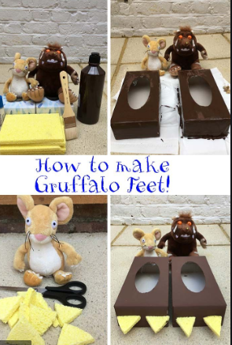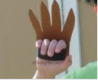  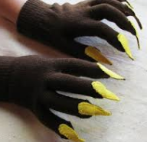 | Play a game of I spy- Change it by saying I spy with my little eye something big or something small etc. | Can you sing If you are happy and you know it?  https://www.youtube.com/watch?v=mHLLclRQ10o | Can you make someone in your family laugh?
Friday | Maths  I am going to close my eyes and describe different objects using key mathematical language:  Big, small, long, thin, corners, wide, fat, pointy, flat, sides, curved.  This activity will be on Seesaw- or you could just give your child an object to describe- you could wrap it up in wrapping paper to make it trickier!   | Can you look in a mirror and watch your mouth make the following sounds?  These are from speech and language plans!  Make a sound of a snake ssssssssssssss  A bee buzzing…buzzzzzzzzz  A ball bouncing….boing, boing, boing  A train , choooo, choooooo  The wind howling ooooooooooooohhhhhh  Can you say sh, sh, sh sh | Can you help sort the washing today?  Can you find the pairs of socks that are the same? | Can you sing Sleeping Bunnies?  https://www.youtube.com/watch?v=BHcFQ9gaMF4&vl=en  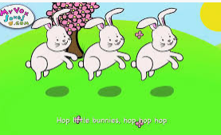  Have a lovely weekend!

Please choose from any of the activities above and have fun learning at home. We would love to hear about what you have engaged in so,
Please send or share any work, photographs or questions to Nursery_homework@templars.coventry.sch.uk

