 | Maths | Phonics | Talk/Rhyme Time | Theme | Story
Monday | Maths  Can you march and count to 10?  Can you do 10 jumps?  Watch 10 Fat sausages sizzling in a pan.  https://www.youtube.com/watch?v=pBjFM-Di7_M    Use your fingers to show how many sausages are left in the pan? | Read Write Inc  Watch Seesaw.  Today we are learning to read the letter  s  It makes a ssssssssssssssss sound, it’s a long stretched sound. Can you make this sound?  Look at all these things they begin with s, sausages, sun, soup, sandwich,socks  Have one object that does not start with this sound, can they spot the odd one out? E.g, monkey! No that does not start with a ssssssss sound!  How do we write the sound?  We say the rhyme ,’Slither down the snake’.  Have a go at writing sssssssssss  Or you could make it using a skipping rope or even spaghetti!   - 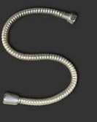 | Can you go on a s hunt around your house?  Can you find 3 things that begin with the sssss sound? | Can you draw/ paint or make a model with something beginning with….s?  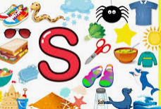 | Listen to story – cbeebies- If I had a dinosaur.  https://www.youtube.com/watch?v=KA1rpm15nj0
Tuesday | Maths  Watch on Seesaw  Place the numbers 1,2,3,4,5 on the floor. Can you read these numbers? When you shout a number can you quickly get pick it up?  Today we are learning number 6. Can you show me 6 fingers?  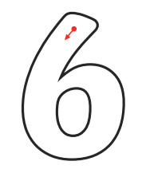  The rhyme is,  ’Come on down and make a curl’. | Phonics  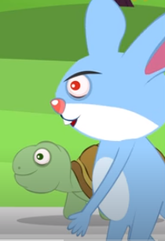  Before the race begins can they guess who is going to win the race?  Watch the story ‘The hare and the tortoise.’  https://www.youtube.com/watch?v=Sv5OItL7eWE  Talk about, How slow and steady wins the race and ,never give up!  Can you have a race with someone at home?  -Who is first and who is last? | FACT: The fastest land animal is a cheetah (70 miles per hour). More impressively, the feline can accelerate from 0 to 60 miles per hour in just three short seconds! That's better than a sports car! | Let’s get FAST AS A CHEETAH!  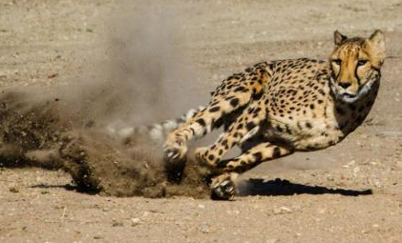  In your garden or living room find a safe place to move!  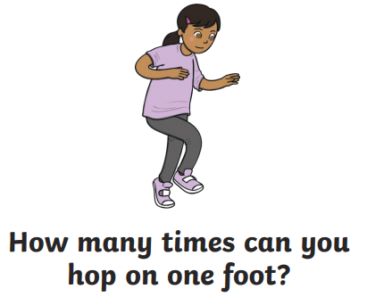  Use cushions instead of cones!  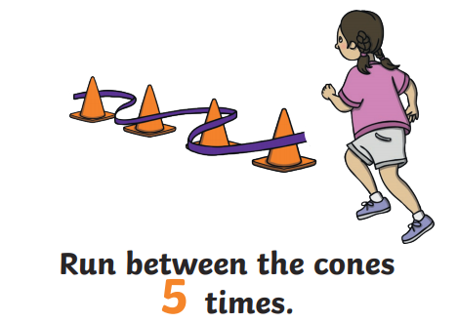 | Listen to story  Read your favourite story today!
Wed | Maths  Watch on Seesaw  Let’s pretend to be a cheetah this morning! The fastest land animal.  Count to 10 really fast!  Jump 10 times really fast.  Do 10 jelly shakes…fast!  Have a go at ‘The hare and the tortoise.’ Adding sheet- it’s on Seesaw.  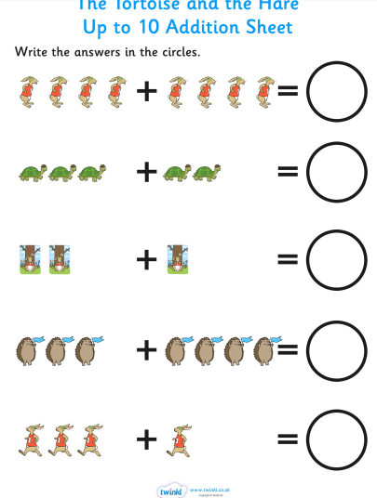 | Phonics  Watch on Seesaw  Watch a story with Mrs Burgess  Unstoppable Me!  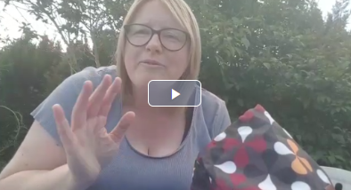 | What is the fastest animal in the sea?  It’s a Sail Fish- 68mph!  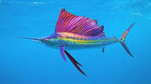 | Who won the race yesterday?  Who was first?  Can they design a medal for the winner?  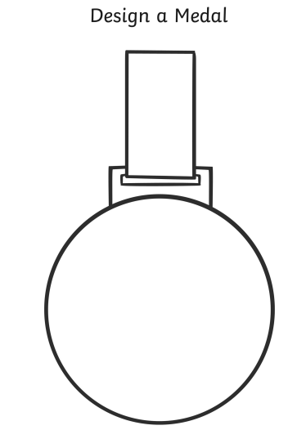  The template is on Seesaw! | Listen to story online Cbeebies Rhyme Crime- read by Mark Ronson  https://www.youtube.com/watch?v=w3bDfvBwEXM
Thurs | Maths  Sing a number song!  (Watch on Seesaw)  One Kangaroo went out to play. (addition song)  Today we are going to use Positional Language.  In front, behind, next to, under, between.  Watch Where’s monkey?  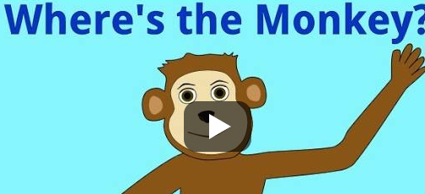  https://www.youtube.com/watch?v=idJYhjGyWTU&list=PLisGMvEDQqYvdNtbcofKhzRk5FWAAtJUu&index=12 | Phonics  Can you make a ssssssss sandwich today?  You have to tell a grown-up how to make their sandwich! What filling are you going to have?  Use super talking!  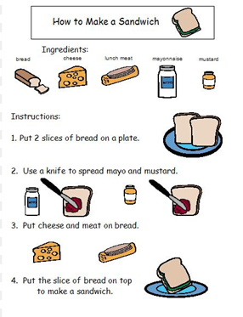 | What is your favourite sandwich filling?  Ask the people in your house.   | Try some of these amazing yoga moves!  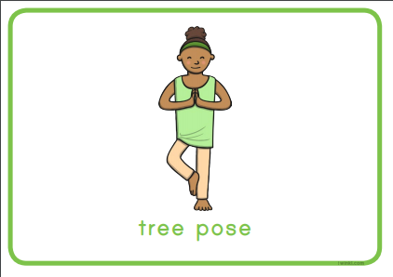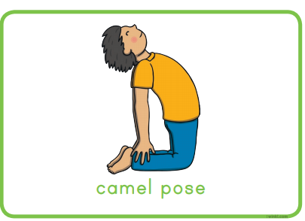  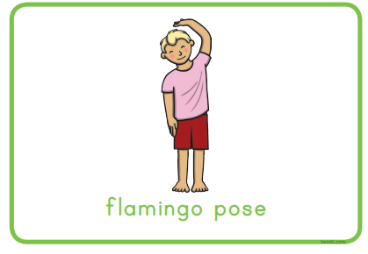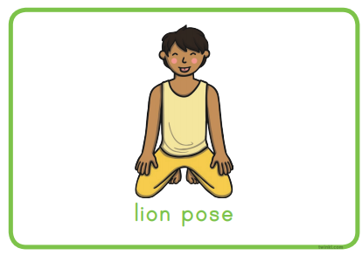  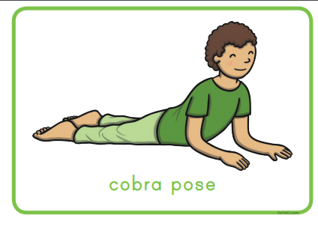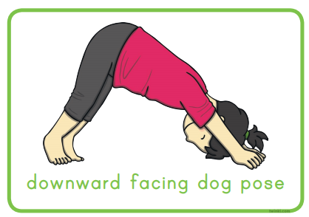 | Watch Harry and his bucket full of dinosaurs  https://www.youtube.com/watch?v=IfLmx2UTGaY
Friday | Maths  Preposition language.  Play Hide and Seek.  Find a hiding place and get someone to count to 10 or 20!  Afterwards you have to tell your grown-up where you were…..using under, behind, next to, beside, between!  ‘I was under the bed’. | Phonics  Read Write Inc lesson  Watch Seesaw.  Today we are learning to read the letter d  It makes a short bouncy, ‘d’ sound.  Can you make this sound?  Look at all these things they begin with  d  dinosaur, dog, dig, dish  Have one object that does not start with this sound, can they spot the odd one out? E.g, teddy! No that does not start with a a a a a a.  How do we write it?  We say the rhyme ,’ Round the dinosaur’s back, up to his neck and down to his feet’.  Have a go at writing d,d,d,d,d,d, | JOKE TIME! What do you call a sleepy dinosaur?  A dinosnore!  What do you call a dinosaur with one eye?  Doyouthinkhe sawus! | Watch this story!  https://www.youtube.com/watch?v=5MMiiXlFNZA  Dinosaur starts with what sound?  d for dinosaur!  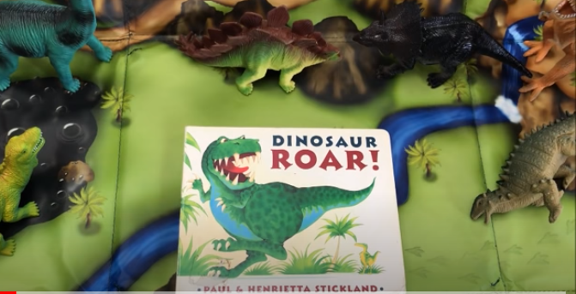

Please choose from any of the activities above and have fun learning at home. We would love to hear about what you have engaged in so,
Please send or share any work, photographs or questions to Nursery_homework@templars.coventry.sch.uk

