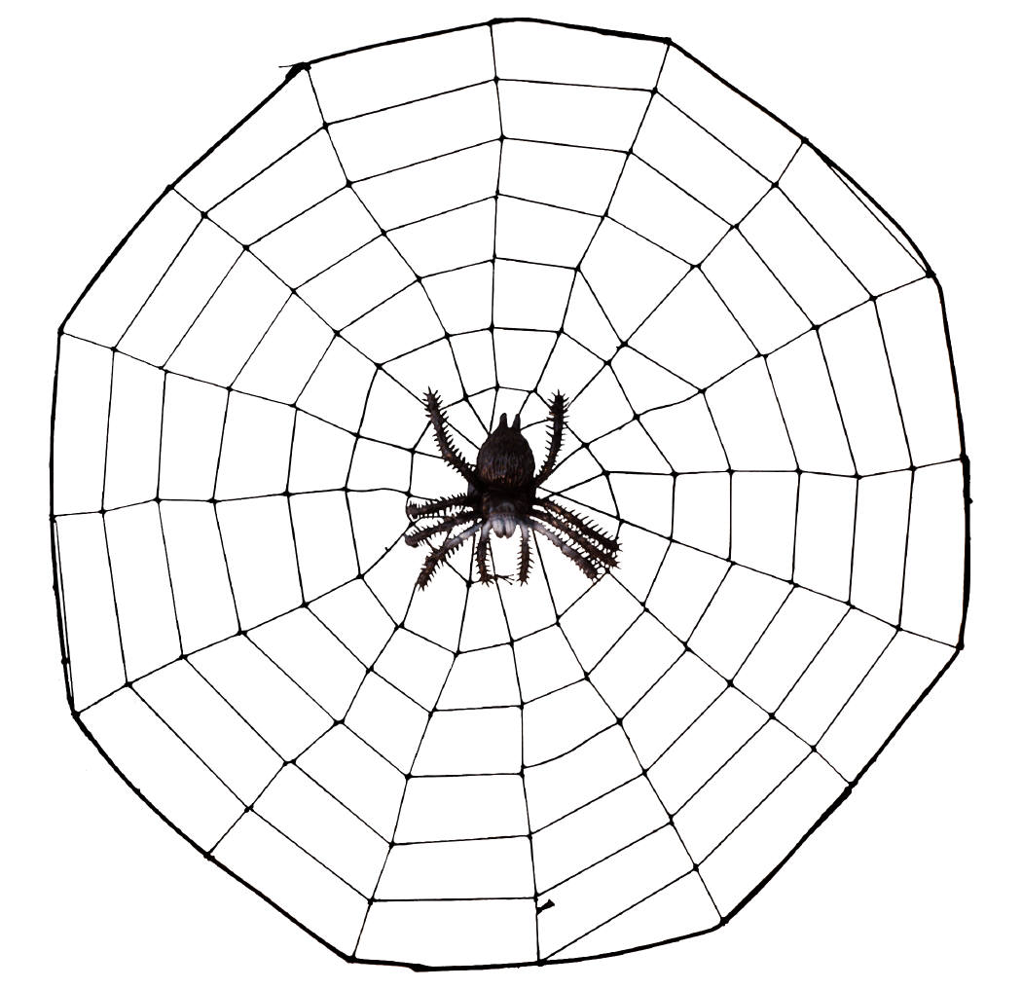

Year 3 Curriculum Web

Spring 2026
Walk Like an Egyptian
‘Be our Guest’ event: 23.3.26
Ways you can help at home...

-Read for 10 minutes at least 4 times a week. Please use Reading Diaries to log your child’s reading.
-Times tables: In Year 3, children will have weekly tests based on 3-, 4- and 8-times tables. TT Rockstars remains an important part of their learning and expectation for home learning as well. The children are expected to do 10 minutes per week at home.
-Spelling: Learning and practicing weekly spellings set.
-PE is outdoors. In Year 3 the children can come to school in their PE kit on PE day. PE Kit: white top, black bottoms and trainers. A warm jumper is also handy!

Humanities
In History, we will be learning about when the Egyptian era started and how long it lasted. We will investigate the different beliefs they had. We will also study the different artefacts that have since been excavated, which will help us to discover more about how they lived. In Geography, we will continue to build on our previous knowledge of human and physical features. We will use a variety of different mapping tools to discover where Egypt is situated and how its position affects the climate and weather it experiences.
In RE, we will focus on Christianity and teachings of Jesus.
The Arts
In Art and Design, we will use a variety of skills and mediums to design and make artifacts from Ancient Egypt. Through the artefacts we discover in History, we will learn how to draw using correct proportions.
In Music, we will learn about Egyptian instruments and how they worked. Children will be composing using their own imagination.

Maths Focus
In Maths we will be learning multiplication & division, Length and perimeter.
Later in the term, we will focus on Fractions, Mass and capacity. We will practise our times tables, every day.

English

In English, we will be using our learning theme as a basis for our writing.
We will be using a variety of speaking and listening techniques to improve our performance and story-telling skills. We will be reading fiction and non-fiction texts based around the Egyptians and we will use this as a focus for our writing. We will begin to use a wide variety of fronted adverbials, clauses and grammar devices to improve our writing. We will write for a wide range of purposes and start to think carefully about our audience and how this affects our writing.

PSHE
We will continue to work with myHappymind programme to help children to understand how their brain works and to support them in developing positive skills and habits to be their best selves. We will also implement My Happy Breathing techniques to help children with self-regulation and to optimize their attention level.

STEM
In Science, we will be learning about nutrition. We will also learn all about food chains and how they are interlinked. We will identify that humans and animals have skeletons and muscles for support, protection and movement.
In Computing we will continue to look at how we can keep ourselves safe online. Children will develop their understanding of what a branching database is and how to create one.

