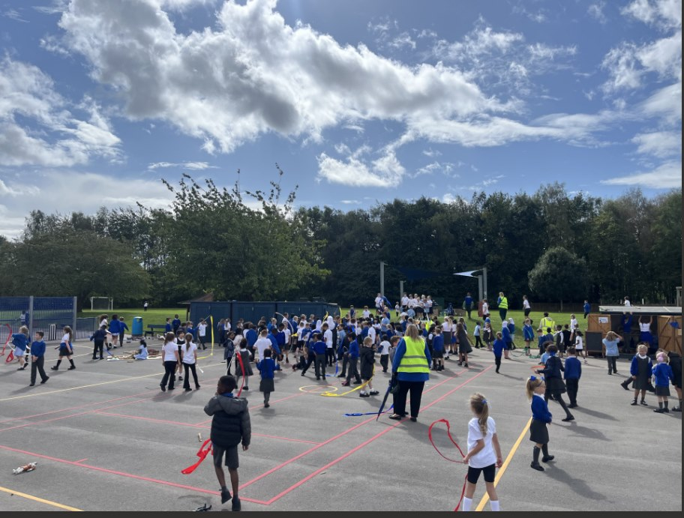

Templars Primary School Newsletter 17.10.25
Date: 17th October 2025
Email: admin@templars.coventry.sch.uk
Dear Parents and Carers,
First of all an apology to Year 6 parents - you have not been in to see classes this year yet but we will be seeing you at Parent's Evening next week.
Next, a thank you because your enthusiasm for the Book Bus earnt us loads of free books in commision to fill up the book shelves in school. It's reassuring that books are as popular as ever, despite the digital competition.
Finally, it’s hard to believe we’re already nearing the end of another busy and brilliant term! The children have worked incredibly hard and brought such energy and enthusiasm to everything they’ve done — from lessons to playtimes and school trips. Staff are so proud of how much they’ve achieved together. As we head into the final stretch, we’ll be celebrating successes big and small and making sure everyone finishes the term feeling proud, positive and ready for a well-earned rest!
Next week at Templars
Parent's evenings - I am sure teachers will be handing out lots of praise for the effort and attainment of your children. If you think teachers are doing a good job, please make sure to tell them too!
We are a No Outsiders school.

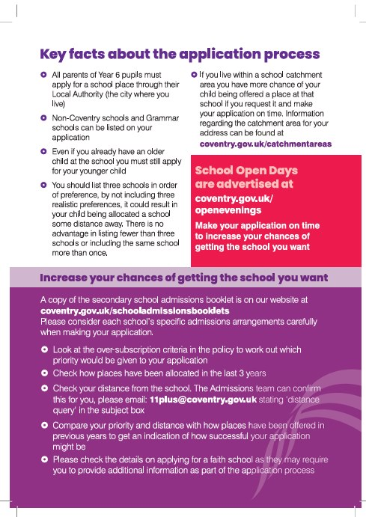

Headteacher's Award 2025-26

The winners below will join me next week.
Each week teachers select a winner per class for achievements, stand out improvement, demonstrating our school values and or great learning behaviours. The winner brings home their certificate and then, on the following Friday, they take part in a celebration tea with Mrs Benarous. At 3pm on that Friday, parents can come to the Community Centre, join in the fun, and or collect early as a special treat.
1KW Cobi for great improvement in his handwriting
1P Jenson for fantastic effort and progress in handwriting and fractions
1C Bella-Rose for always making right choices
1S Charlie for showing great care in his writing
2M Rian for working hard and showing our school values
3D Alex for always following school rules and your great attitude towards learning
4A Nyjha has worked really hard in following our school rules and values
4AR Willow for her new-found confidence
4H Natan for showing a sense of humour during our spelling lesson and participating more frequently in class
5F Lidia for her thoughtfulness towards others, pride in her work and always being polite
5G Safiya for consistently showing our school value of respect
5H Sarim for consistently showing care, respect and honesty
6B Harley for amazing all round effort!
6T Mikey for growing in confidence to participate in class discussions
6M Orlagh-Rose has been working really hard during lesson time

Lunch Menu for next week
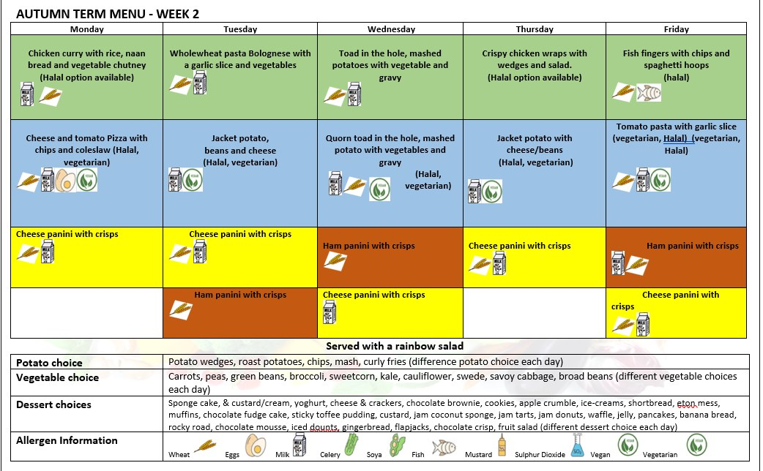
Please note we will return to Week 1 after half-term

Dates and Events
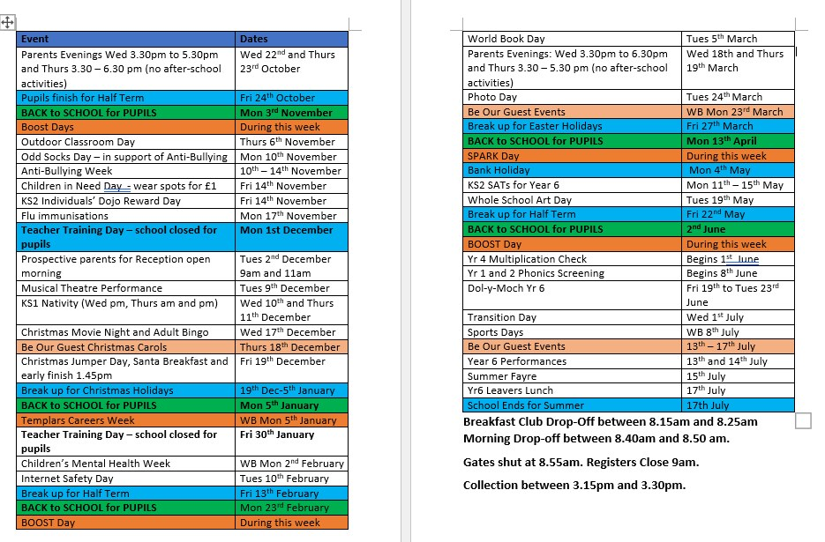

Community Activities for Children
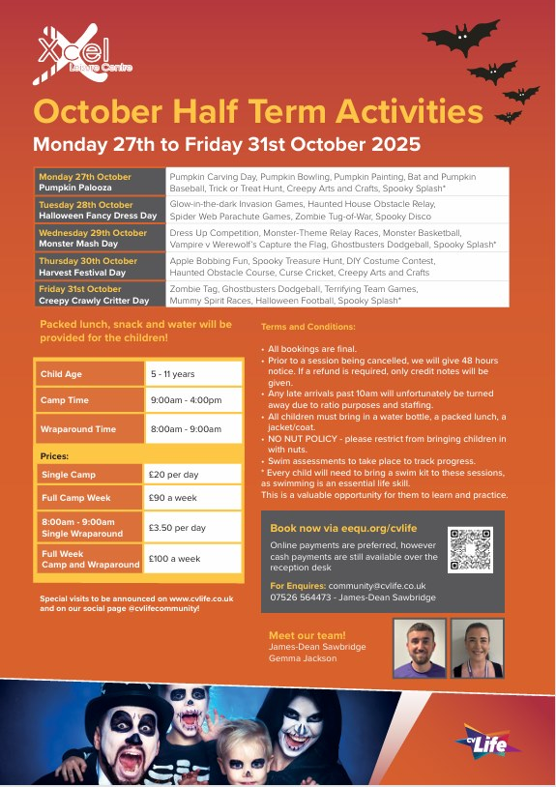
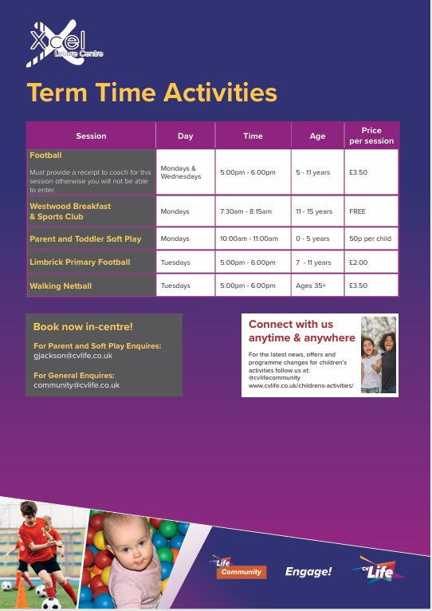


Parent Support


