
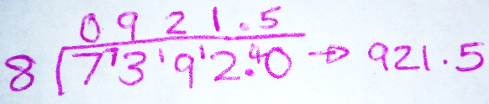
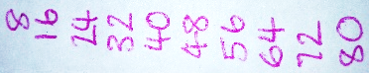
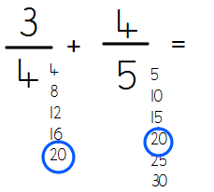
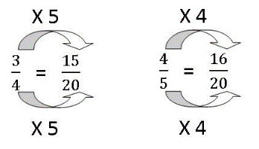
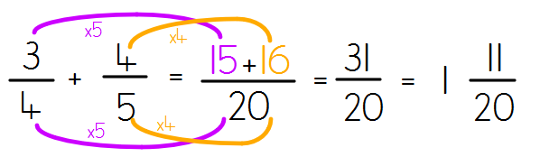
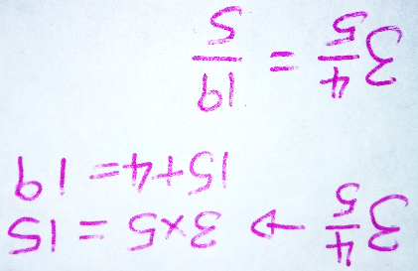
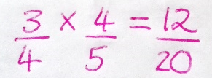
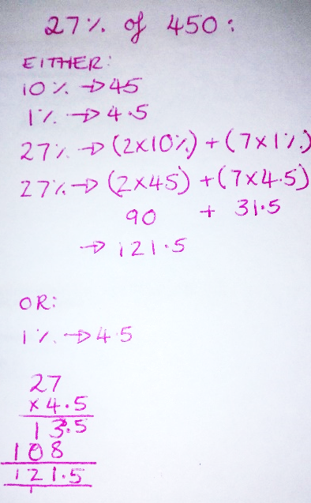
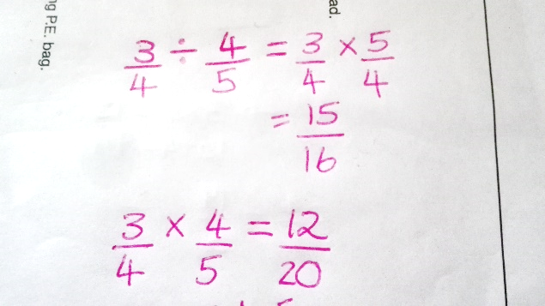
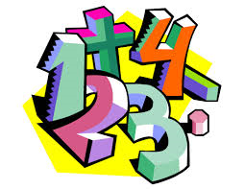
The Golden Rules of Arithmetic:
- You don’t need to simplify your answers for this test
- Read the question. Then read it again. And then again before you answer.
- If you finish, go back through. Imagine every question is wrong and check everything. You probably won’t have 100%!
- The better you do in arithmetic, the less pressure is on papers 2 and 3!
6S- Miss Stuart
Kaikoura.stuart@templars.coventry.sch.uk
Percentages
- Find 10% by dividing by 10. Find 1% by dividing by 100.
- Use your 10% and 1% to ‘build’ the required amount.
OR
- Divide by 100, then multiply by the % you need.
Dividing whole numbers
- Write a list of multiples of the divisor.
- Working from left to right through the dividend, work out how many times the divisor goes into each digit. Write this above the bus stop and write the remainder next to the next digit to the right.
- Continue process until there are no digits and no remainders left.
Adding and subtracting fractions
- The denominator MUST be the same. If it isn’t, find the lowest common denominator.
- Complete the same multiplication to the numerator as to the denominator.
- Record your working.
Converting between mixed numbers and improper fractions
- Multiply the whole number by the denominator
- Add the answer to the numerator
- Write that answer over the denominator
Multiplying fractions
- Multiply the numerator
- Multiply the denominator
Dividing fractions
- ‘Fraction and Divide, Kiss and Flip’
- Keep the first fraction the same, change the division sign to a multiplication.
- Flip the second fraction upside down.
- Answer the multiplication.
Paper 1- Arithmetic- Knowledge Organiser

